Networks - Design

# Architecture

## Small Network

Small networks such as those in homes are commonly designed for minimal cost, meaning the network is compact and the router is normally combined with the modem and switch. Another common part of design is chaining switches together as the network expands.

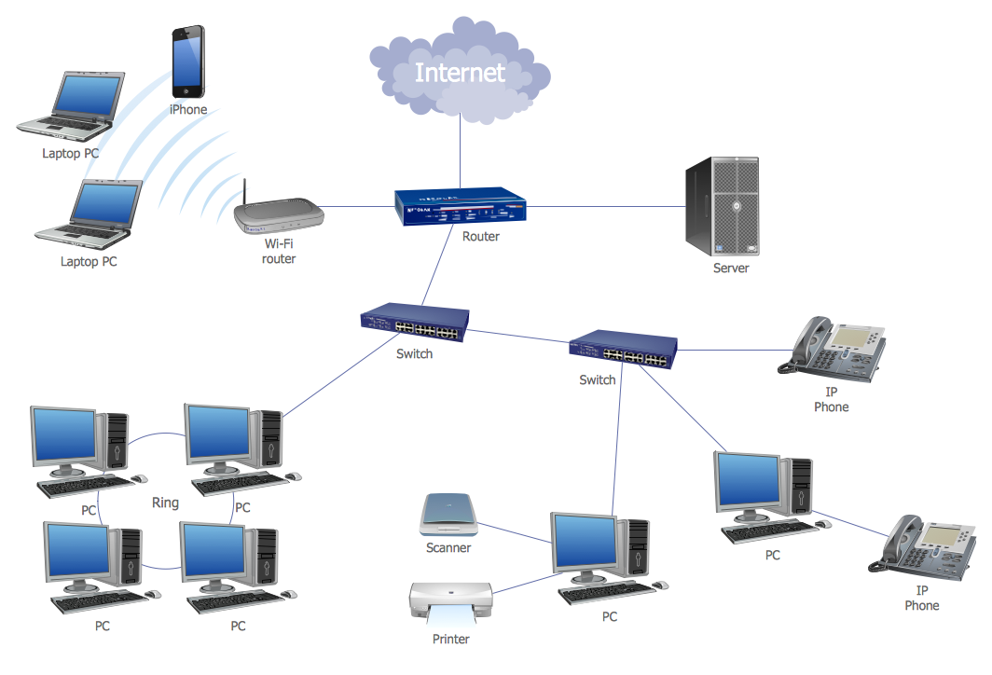

This style of network design leads to mutliple single points of failure, where is a single cable or unit is damaged, the whole or large parts of the network will go down. In a business this style of network is dangerous, since large downtime can lead to poor service and significant profit loss.

## Campus Network Design

Good network design provides as much redundancy as possible for the budget allowed. In order to provide redundancy, each switch must connect to more than one switch. To do this in campus design there are several layers to the network:

* Access layer: access switches are connected to client devices
* Distribution layers: distribution switches are connected to the access switches; they tend to be layer 3 switches making them very heavy duty and expensive
* Core layer: High speed backbone, switching pckets to optimise communication on the network. The core layer does not perform any packet manipulation which would slow down switching.

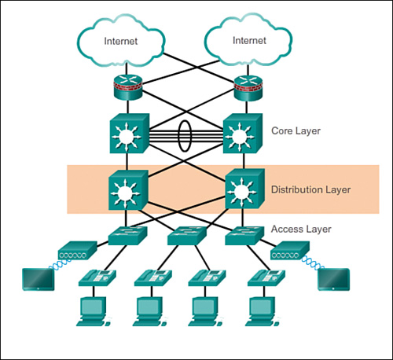

Collapsed core models use the distribution layer to manage connections to other campus networks.

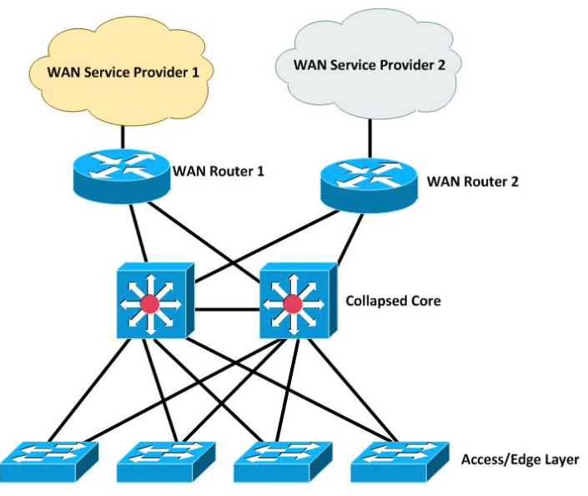

The campus network design allows for good north-south data transfer (i.e. client to internet).

## Datacenter Network Design

Since datacenters contain many machines which are often connected in distributed system. Very fast interlink speeds, east-west data transfer (i.e. client to client), are required. Due to the number of hops required for client to client transfer in the campus network design, a different design is needed.

Modern datacenters have two layers:

* overlay - connect to internet and provide automation within the network
* underlay - connects all clients

### Underlay - Spine/Leaf Design

Spine-leaf design is used in modern data centers to ensure fast east-west tranfer:

* Leaf - each leaf is a switch based in the server rack connected to all the application servers (clients) in the rack and all spines in the system
* Spine - each spine is connected to all the leafs in the system

.

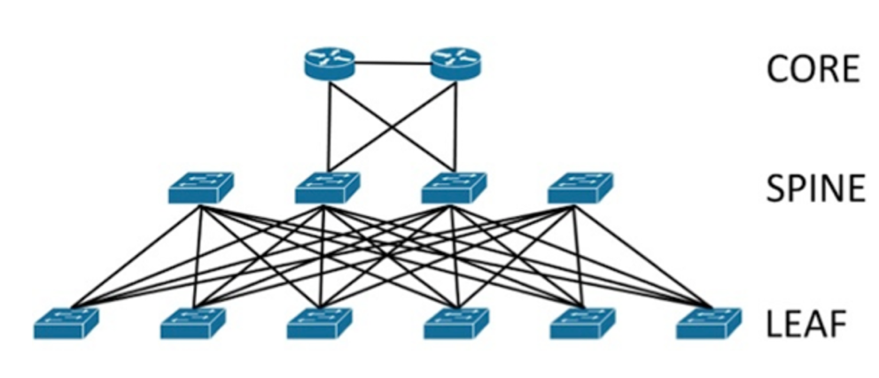

Since all leafs and spines are meshed to eachother, there is a maximum of 2 hops from any client to another, making response times very quick. The main downside to this system design is the number of cables involved.

Typically, connections between leaves and spines are layer 3. This gives a few advantages:

* links avoid being blocked by spanning tree (l2 loop prevention)
* links can be load balanced